ΕΘΝΙΚΟ ΚΑΙ ΚΑΠΟΔΙΣΤΡΙΑΚΟ ΠΑΝΕΠΙΣΤΗΜΙΟ ΑΘΗΝΩΝ  ΦΙΛΟΣΟΦΙΚΗ ΣΧΟΛΗ  ΤΜΗΜΑ ΦΙΛΟΛΟΓΙΑΣ  ΠΑΝΕΠΙΣΤΗΜΙΟΥΠΟΛΗ  ΑΝΩ ΙΛΙΣΙΑ – 157 84 ΑΘΗΝΑ | 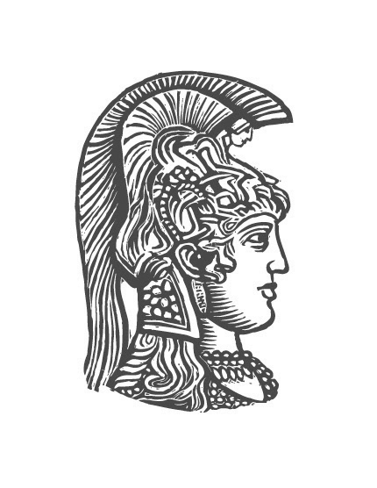 | NATIONAL AND KAPODISTRIAN  UNIVERSITY OF ATHENS  SCHOOL OF PHILOSOPHY  FACULTY OF PHILOLOGY  PANEPISTIMIOUPOLI  ANO ILISIA – 157 84 ATHENS

ΠΡΟΣΚΛΗΣΗ
Τη Δευτέρα 8 Απριλίου 2024, ώρα 12.30 μ.μ.,
θα πραγματοποιηθεί στο πλαίσιο των «Επιστημονικών Συναντήσεων»
που διοργανώνει ο Τομέας Κλασικής Φιλολογίας του Τμήματος Φιλολογίας του Ε.Κ.Π.Α.,
σε συνεργασία με τα Π.Μ.Σ. του Τομέα Κλασικής Φιλολογίας («Κλασική Φιλολογία–Δέξιππος», Λογοτεχνία Σκέψη και Πολιτισμός στον Ελληνορωμαϊκό κόσμο», «Παπυρολογία και Κλασική Γραμματεία») η ομιλία του κυρίου

PHILIP HARDIE
καθηγητή στο Πανεπιστήμιο του Cambridge,
με θέμα:
«The Sublime in Augustan Poetry and Lucretius».

Η ομιλία θα πραγματοποιηθεί στην αίθουσα 209.

Σας προσκαλούμε να παραστείτε.

Ο διευθυντής του Τομέα Κλασικής Φιλολογίας
Αμφιλόχιος Παπαθωμάς

Συντονιστές
Αικατερίνη Κορολή Βάιος Βαϊόπουλος
katkoroli@phil.uoa.gr vaiosvaiop@phil.uoa.gr

Philip Hardie
The Sublime in Augustan Poetry and Lucretius
The Augustan period in ancient Rome grew out of, and resulted in, the transgression and testing of boundaries. The new order of the principate emerged from the chaos of the civil wars prior to Octavian’s final victory at the Battle of Actium, and the ideology of the one man who was now de facto sole ruler in the Roman world was formed in part through the magnification of pre-existing ideas about the spatial and temporal extent of Roman conquests, and about the status of the one man who led Rome at home and abroad. A poetics of the sublime of forces both destructive and constructive finds expression in the central and defining text of Augustan poetry, Virgil’s Aeneid. In literary-historical terms, Virgil’s epic is engaged in a titanic agon with the founding texts of Greco-Roman sublimity, Homer’s Iliad and Odyssey. Gigantomachy, by convention one of the loftiest poetic subjects, informs the Aeneid’s representations of colossal events in both the natural and the human worlds, beginning with the inaugural and hyperbolical storm in book 1, which, on the level of the physical structure of the cosmos, threatens to return the world to chaos, and which, on the level of political imagery, replays the catastrophe of Roman civil war. The poem ends with the embodiment in its hero Aeneas of the forces of the storm and the supreme storm-god Jupiter, as he strikes down his enemy Turnus in an uncontrollable and terrifying excess of furious emotion. Aeneas and his Julian descendants are destined to go beyond the mortal in a posthumous elevation to divinity in the fiction of imperial apotheosis, a powerful resource for the sublime self-representation of the ruler for centuries to follow.
A crucial model for the imperial theios anēr (‘divine man’) is Epicurus, the sublime hero of the intellect in Lucretius’ late-republican didactic poem On the Nature of Things, whose flight of the mind ‘beyond the flaming walls of the world’ is imitated in many later sublime flights of science and poetry, for example Manilius’ late Augustan, and high-flying, didactic poem on astronomy, the Astronomicon. The paradox that Lucretius’ quietist hero of the mind should be reflected in Virgil’s proto-imperial epic hero is lessened by the fact that Lucretius’ Epicurus is a figurative Alexander the Great, the world-conqueror whose desire to journey beyond the Ocean that encircles and limits the world was the subject of declamations in the late first-century-BC rhetorical schools, as recorded in Seneca the Elder’s first Suasoria, and whose achievements were the object of emulation by powerful men in Rome, Pompey, Julius Caesar, and Augustus.
The impact of the Lucretian natural-philosophical sublime on all of Virgil’s works, and on post-Virgilian epic, is profound, and it is also a major stimulus to Horace’s conflicted management of the impulse to the sublime, alternately euphoric and depressed. In the Odes, Horace is tempted by the Pindaric sublime, but is aware that this may be a temptation to an Icarian flight. Ovid’s Metamorphoses offer large-scale examples in the Lucretian and Virgilian sublime, most notably in the story of Phaethon (with an extensive reception history); Ovid also tests the boundaries between the sublime and the ridiculous. In his poetry of exile, Ovid is constantly oppressed by the ‘thunderbolts’ of a Jovian Augustus, an incomprehensible figure of omnipotence in the face which the poet’s soul is unable to rise in sublime superiority. One can only guess how far Ovid’s lost tragedy, the Medea, may have travelled in the direction of the sublime excesses of Senecan tragedy.

